- Usage of e-Leave Module
  - Calendar View
    - Introduction
2.1.1.1 Press [Calendar view]
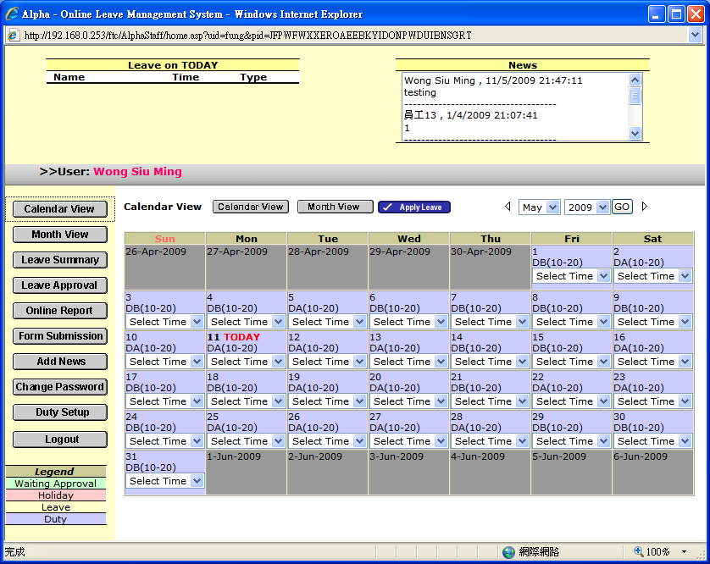

2.1.1.2 Select [Date Range] and press [GO]

or Press『』/ 『』to display previous or next month calendar

Legend
Yellow： Leave Day
Green： Waiting Leave Approval Day
Red： Holiday
Blue： Normal Working Day

